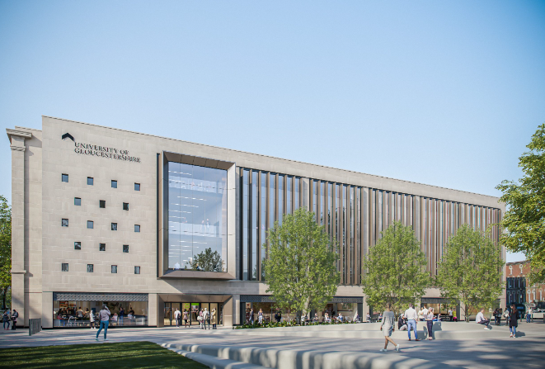

“The Arts, Health and Wellbeing Centre is a unique, vibrant and welcoming space where community, creativity and research come together to promote social connection and reduce health inequalities” Gloucestershire Stakeholder Group
One Gloucestershire and the University of Gloucestershire are funding a range of half to one day workshops at the University of Gloucestershire’s Arts, Health and Wellbeing Centre at Gloucester City Campus GL1 1RP.
For further information and to book a place please contact anne.howe4@nhs.net
The workshops are free of charge, however we would be grateful if you could let us know if you no longer need your place as we usually have waiting lists for our workshops.
Title | Duration | Audience | Date
*Walking Together: Insights from Walk In My Shoes  Walk In My Shoes WIMS Gloucester | Half day | Health and care staff, VCSE, researchers and university students interested in diversity and inclusion | Tuesday 17th February 2026, 9.30am (for 10am start) until 12.30pm
*Walking Together: Mentoring for Diversity in Healthcare | Half day | Health and care staff, VCSE, researchers and university students interested in diversity and inclusion | Tuesday 24th February 2026, 9.30am (for 10am start) until 12.30pm
‘Deeper Representation’ – research enquiry presentation into data findings of how to engage seldom heard communities | 1.5 hours | Open public lecture – just turn up, no need to book in advance | Tuesday 24th February 2026, 5 to 6.30pm
Dementia Film Showing – a powerful series of highly commended ‘fly on the wall’ short films showing the lives of people with dementia living in a care home and supported living | 1.5 hours | Held in the lecture theatre on 1st floor.  Open to members of the public, health and care professionals, VCSE and independent sector | Thursday 5th March 2026, 5.15 to 6.30pm
*Celebrating Women in Health: Stories, Leadership, and Wellness | Half day | Health and care staff, VCSE, researchers and university students interested in women’s health and diversity | Thursday 5th March 2026, 9.30am (for 10am start) until 12.30pm
^Qualitative and arts-based methods in music therapy research; experiences of using Interpretative Phenomenological Analysis and music microanalysis in a PhD exploring Music therapy and later stages of dementia' | Half day | Health and care staff, VCSE, researchers and university students interested in qualitative research in creative health | Tuesday 17th March 2026,  9.30am (for 10am start) until 12.30pm
^The power of music therapy for later stages of Dementia. An interactive workshop | Half day | Health and care staff, people and communities, VCSE, charitable, independent sector, UoG undergraduates and postgraduates | Tuesday 24th March 2026, 9.30am (for 10am start) until 12.30pm

* These sessions are facilitated by Valerie Simms, Founder of Walk In My Shoes CIO (Charity number: 1204479), and where relevant, she may invite guest speakers to share lived experiences, ensuring the workshops are engaging, practical, and impactful for attendees.
^These sessions are facilitated by Maggie Grady, CEO of Mindsong. Mindsong creates and provides services across Gloucestershire that are tailored for people living with dementia and their family and friends, helping to support wellbeing, decrease isolation, develop new relationships, and bring joy through music. They offer clinical music therapy sessions, community singing groups and volunteer-led singing with residents in care homes. They also aim to increase awareness and understanding of dementia through training and education.

